Testing

Visitor

**Register**

Visitor need to fill in email and password and the password should be having at least 6 characters long, one non letter or digit character and one lowercase and one

uppercase.

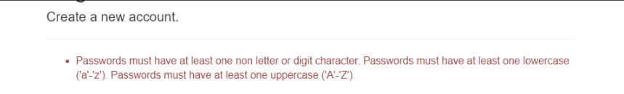

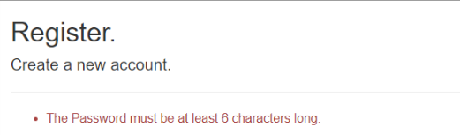

**Visitor cannot create the post**

When visitor want to create a new movie, forum or people details. Website will show visitor need login first.

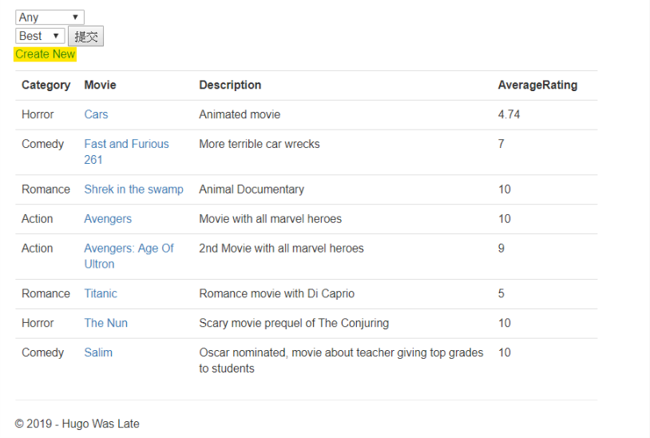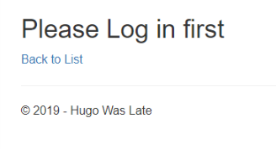

**User-Login**

User need to enter the correct email and password to login.

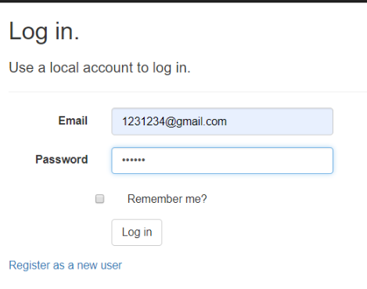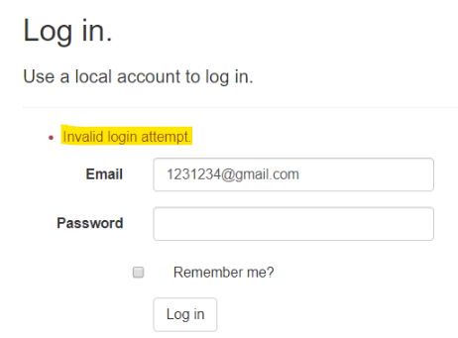

**Create New Movie**

When user do not put value on the test box, that will show the error messenger.

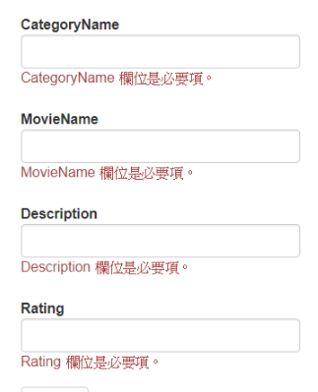

If the user put non -number in the rating test box, that will show the error messenger.

